**Radical Conversion**

Inspiration

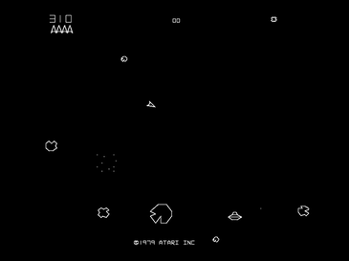 For this brief of radical conversion, I really wanted to create something unique but that has clear connections to both the original game and code and to outside inspirational factors. My first inspiration for my game was Asteroids which was a game released by Atari in 1979 and is a gaming classic. I loved the games simplicity and setting which provided a great game feel for the game creating very tense and exciting game play. I wanted to carry this setting forward into my game updating it with more modern-day graphics but still keeping the classic pixelated aesthetic. In addition, I loved how even though this games mechanics were extremely simple it was not an easy game and getting a good high score would require a lot of skill which is where the game became far more entertaining and interesting.

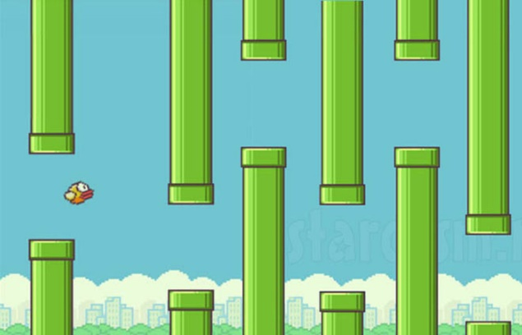

My second source of inspiration was obviously Flappy bird as this was the code I had to radically convert for the project. What I liked about Flappy bird was its mechanics and once again how they were so simply yet provided the player with very challenging and frustrating game play. The one button and axis movement was the key to this keeping it very simply and required the player to have good timing and an understanding of these mechanics in order to succeed. These are the parts of the game I wanted to carry through into Asteroid Field.

Concept

The concept for my game is very simple. I wanted to combine the mechanics and gameplay elements of flappy bird, with the style, theme and aesthetic of an updated asteroid. I wanted my game to have a futuristic sci fi setting but with done so in a pixelated art style because I think this is a very interesting combination which creates a very classic feel for the game. The theme of my game places the player in a ship in space as you start to fly through space you enter an asteroid field, the player must simply see how long they can survive in the brutal conditions of an asteroid field seeing just how many asteroids the can dodge. In terms of mechanics I wanted to keep flappy birds one button “flap” like mechanic for the players ship to propel it through the asteroid field with a high send of gravity which pulls the ship down to the bottom of the screen.

Development Process

To begin my project, I started with the original flappy bird style game we coded. I used this as a base point as I wanted to keep many of the features so this would give me a very easy template to use. I started by creating all the assets I wanted to use in the game as I began mind mapping what I need to create. I knew I needed to create a background, player ship, asteroid, explosion and enemy ship. As I knew I wanted to use a pixel art theme I opened up google and started to look at some pieces for inspiration, after I did enough research and had a good idea of how I wanted things to look I used corel paint shop pro and began designing the pieces. When I was finished I Implemented all the ones that I could into the game which where the background and the players ship. I found that the player ship was far too large when I imported it so I had to scale it down in the code. When I was happy with these two assets I was still left with pipes and all the other flappy bird mechanics. The first thing I wanted to change was to make the player not be able to fly off the screen so to do this I added code to set the world boundaries which solved my first issue. Next I didn’t want the player to die as they hit the floor like they do in flappy bird so I had to remove this code. Was I was happy with the player and its movement I began working on the obstacles that the player would come up against. I started by removing all the code for the pipes and add code instead that was very similar but would make and asteroid start at the far right hand side of the screen but its y position would be a random number between the height of the screen. This meant that instead of pipes coming along the screen asteroids would. However I found that the asteroids where still coming at the same rate as the pipes which made the game very easy so after play testing I found a good rate at which the asteroids should enter making the game challenging but possible once the mechanics where mastered. I kept the original scoring mechanic as when you pass an asteroid your score goes up by 1 as thought this worked very well and was fun to the player to see how many asteroids they managed to dodge before crashing. Then I added sound effects to when the player hits and asteroid and also an explosion image as I thought this would add to the game feel. Finally I added a end screen game state with an image of your crashed ship which would tell you how many asteroids you managed to dodge as I thought this was a massive polish improvement on just the game restarting instantly.

Problems

I cam across many problems during the development process some which I managed to over come and others that I didn’t. first of all I tried to add enemy space ships that would spawn and shoot the player. I thought this would add a lot more depth to game however after a long time trying to get this feature in the game I found that it actually made the game too difficult and took away from the original simplicity I desired. Next I was going to add asteroids that came at regular intervals a long the top and the bottom of the screen to stop the player sitting in these locations and getting lucky with the randomised asteroids and getting a really high score very easily however, when I added this I found that it made the game once again far too difficult as it didn’t work well along side the random factor as it left the player doomed with no chance of escape too frequently to make the game fun so I removed it.

Future Upgrades

In the future there are few things I would like to add to improve the game. First I would like to spend time to find a way to add alien ships without making the game too complicated as I feel it would add perfectly to the theme of the game. Also I would like to find a way to make it so the player cant sit at the top and bottom and get a high score easily in a balanced way which makes the game fair. Finally I would like to add a high score function so that the players can have more fun trying to beat a record that’s recorded for them.

https://github.com/HarveyBond/gad405-2-assignment